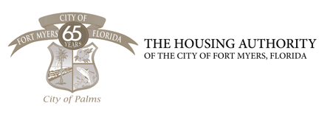

NOTICE

The Housing Authority of the City of Fort Myers Board of Commissioners will hold their annual Board Retreat on Tuesday, June 17, 2025 from 12:30 PM to Wednesday, June 18, 2025, 2:00 PM at Sunseeker Resort Charlotte Harbor 5500 Sunseeker Way, Charlotte Harbor, FL 33980

Please contact the HACFM Office for assistance if needed.
Phone: (239) 344-3222
Email: anastasiaM@hacfm.org

BOARD OF COMMISSIONERS
MEETING AGENDA
June 17 – 18, 2025

Sunseeker Resort

CALL TO ORDER
MINUTES
PUBLIC INPUT/COMMENTS
CHAIRMAN/ EXECUTIVE DIRECTOR
COMMITTEE UPDATES
RESOLUTIONS
OTHER BUSINESS
ADJOURNMENT

